ECPHRASTIC POETRY ACTIVITY
COMPUTING

Using the given stimulus material, create the following types of poetry:
- Free verse
- Acrostic
- Cinquain
- Haiku
- Limerick
Remember to complete the following steps:
- View a stimulus image and identify a computing-related concept it evokes.

- If required, write down the concept, definition, law, formula etc.

- Identify a suitable poetry type and write the poem.

STIMULUS IMAGE 1
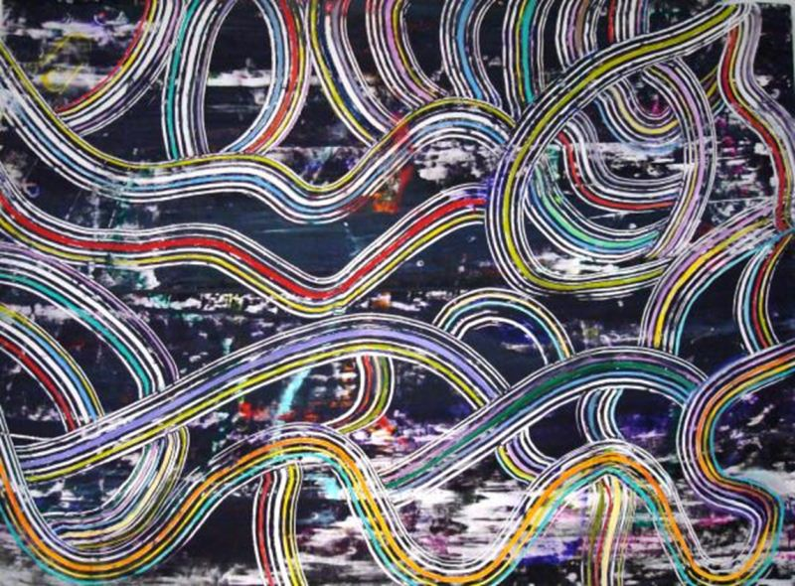
http://images.fineartamerica.com/images-medium/information-super-highway-angelo-ingargiola.jpg
STIMULUS IMAGE 2
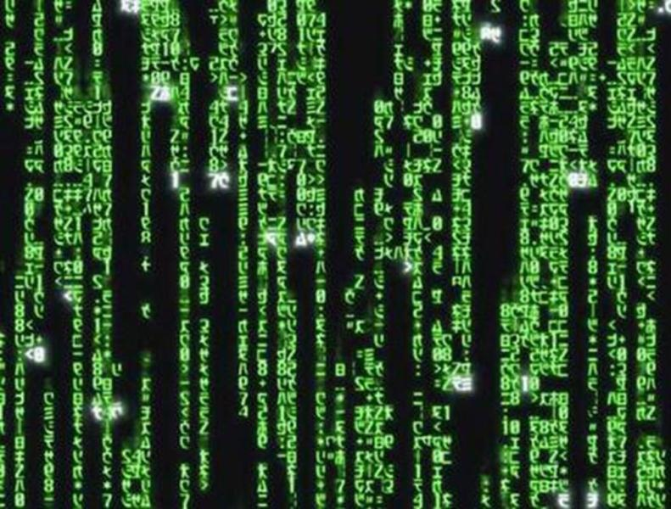
http://about-a-fish.com/wp-content/uploads/2010/03/the-matrix.jpg

STIMULUS IMAGE 3
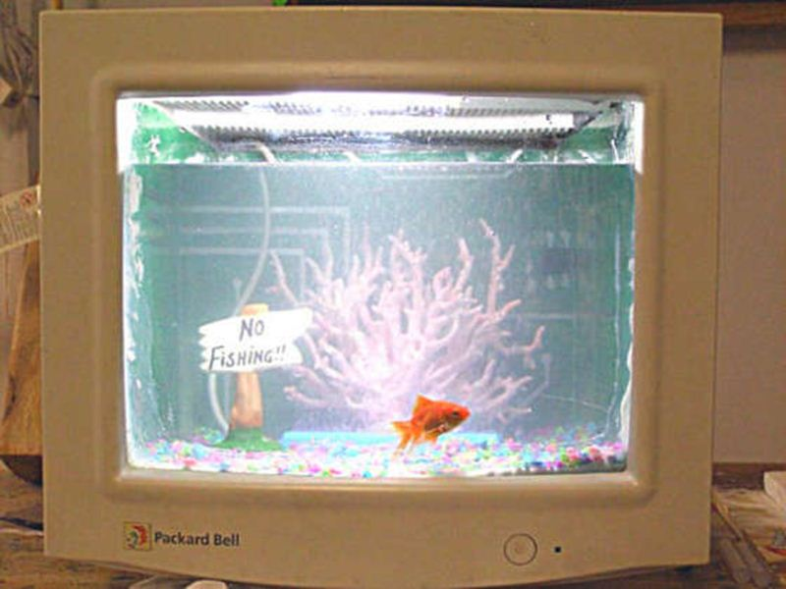
http://www.instructables.com/files/deriv/FVH/GPOB/F3KLNV83/FVHGPOBF3KLNV83.MEDIUM.jpg

STIMULUS IMAGE 4
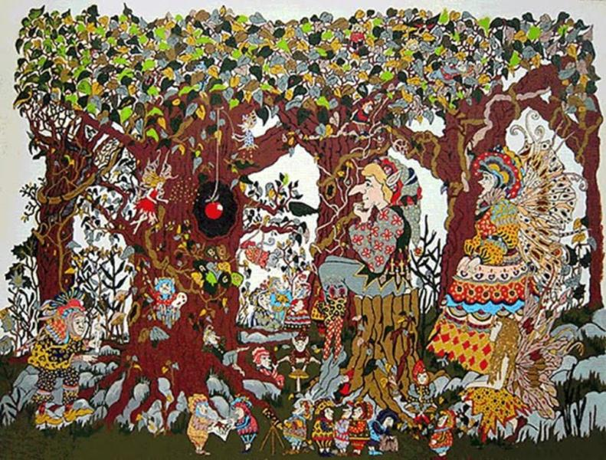
http://theplayfulpixies.blogspot.com/2010_04_01_archive.html

STIMULUS IMAGE 5
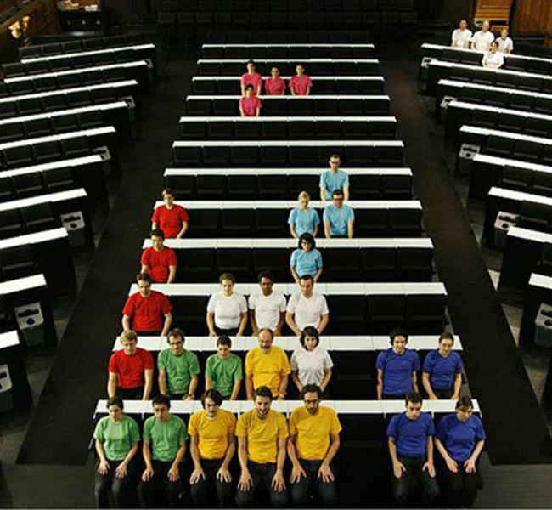
http://media.techeblog.com/images/stopmotion.jpg

